2016

Studio Project 2

Proposal for SPace control game

GOH ZHENG YUAN

Wong KEng Han Ashley

gabriel d’cotta

neo zheng rong

Idea: Space Control Station

Description: You play as a leader of a space station. You’re role is to direct Space Ships to the space station while avoiding contact with other Space Ships or asteroids. You also have to defend your station from incoming asteroids.

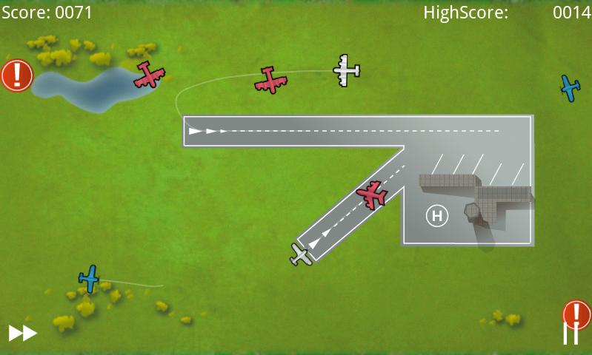

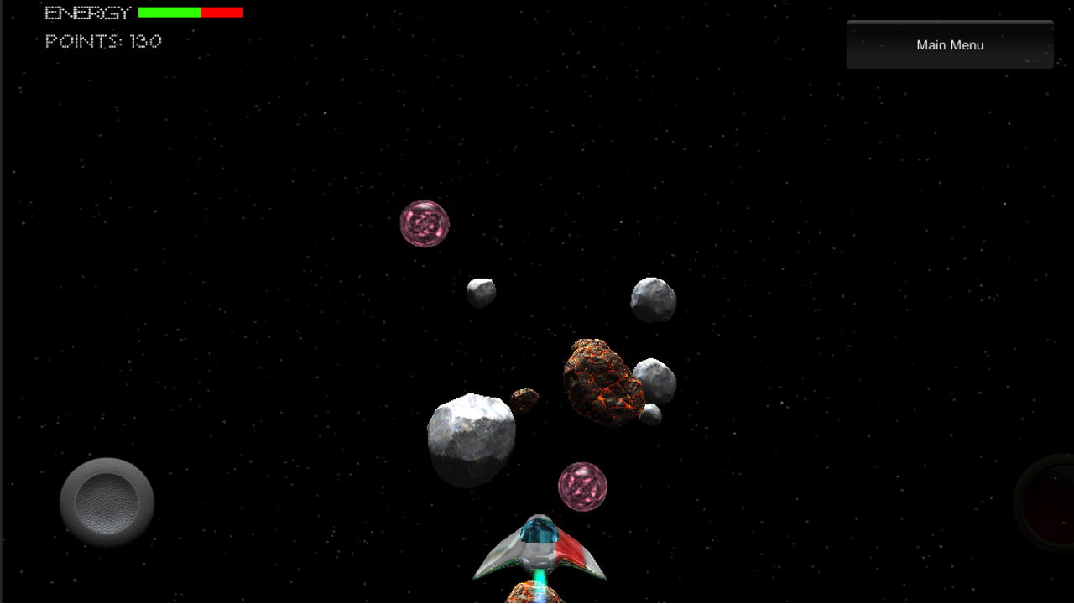

Skybox Size:

1000 X 1000 X 1000

OBJS:

* Control panels (to navigate between areas)
* NPCs
* Spaceships
* Asteroids
* Main Ship.

Characters:

* 5 Space Station Crew
* 4 Space Ships
* 1 annoying sidekick.

NPCs:

* Ships
* Crew members
* Quest NPCs

Scenario:

* Defend the station from asteroid.
* Direct the ships to station.
* Walking around space station to talk to NPCs.

Interactions:

* Bullets Collision
* Talking to NPC
* Moving ships to the station.